Pictograms-Questions
Key Stage 3: 2003 Paper 1 Level 3-5
1.
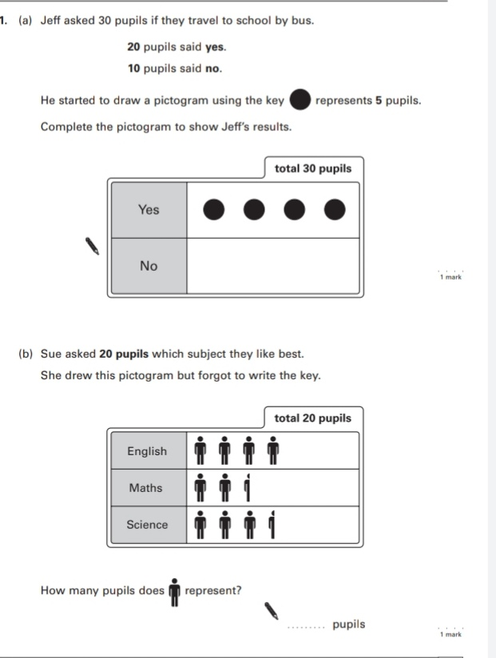
Key Stage 3: 2005 Paper 1 Level 3-5
2.
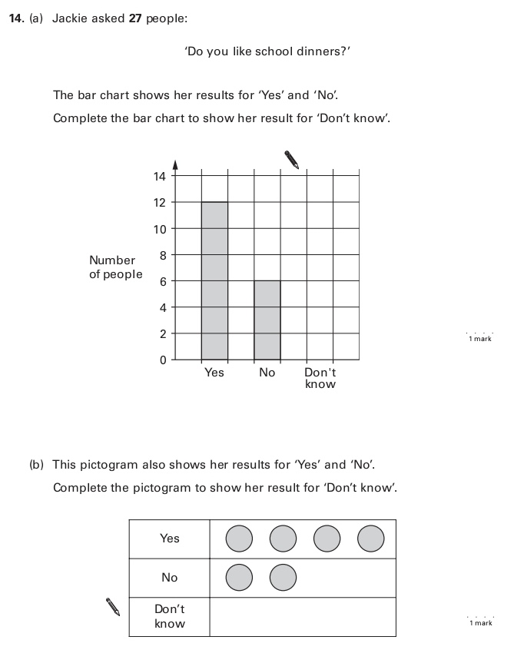
Key Stage 3: 2005 Paper 1 Level 4-6
3.
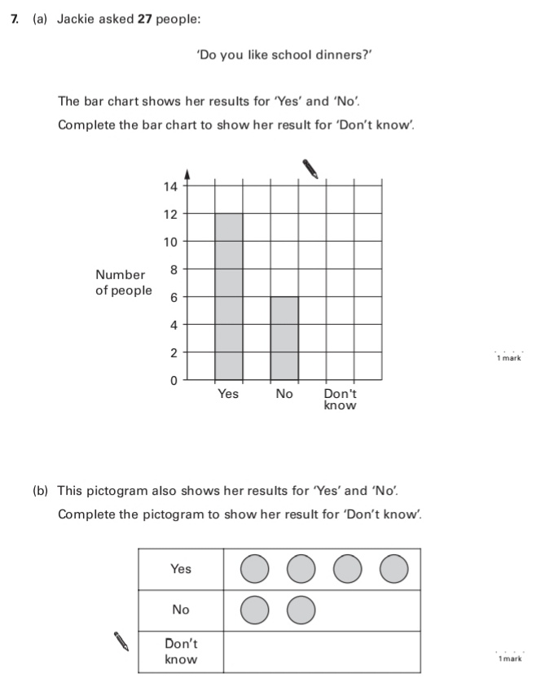
4.
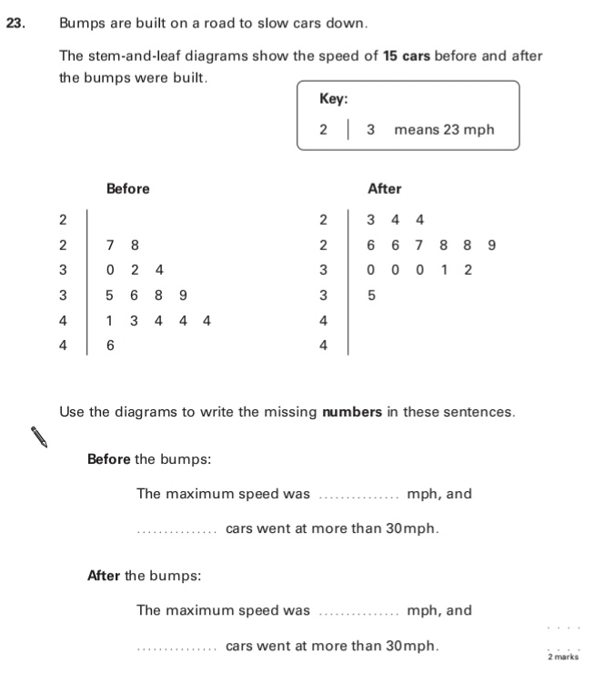
Key Stage 3: 2006 Paper 2 Level 3-5
5.
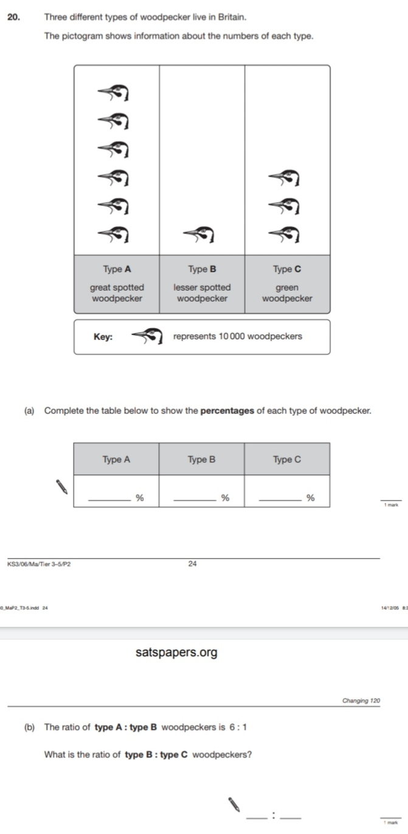
Key Stage 3: 2006 Paper 2 Level 4-6
6.
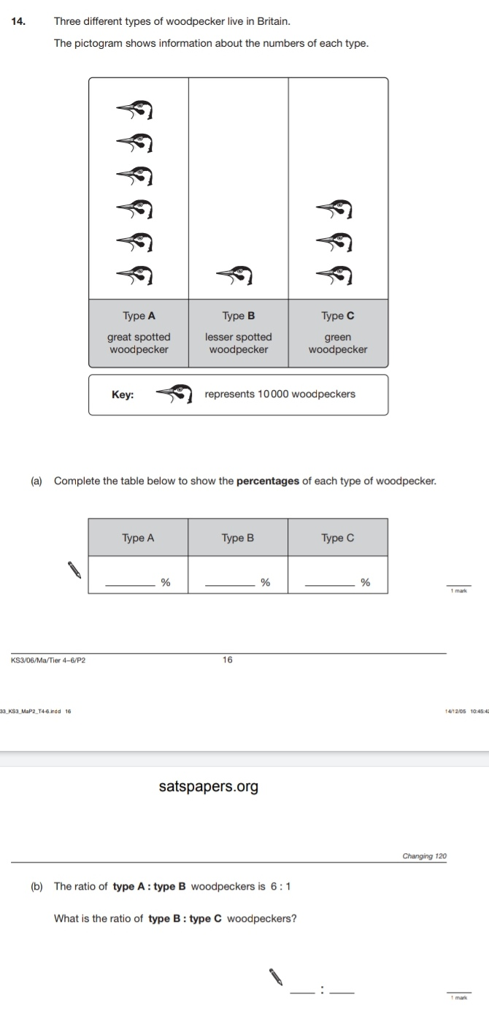
Key Stage 3: 2008 Paper 2 Level 3-5
7.
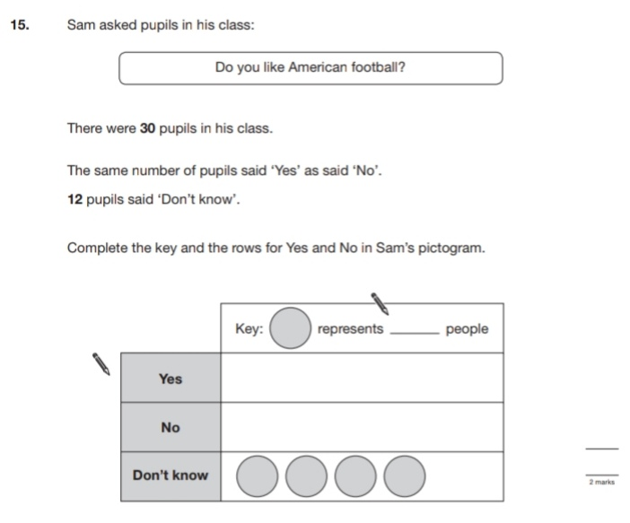
Key Stage 3: 2008 Paper 2 Level 4-6
8.
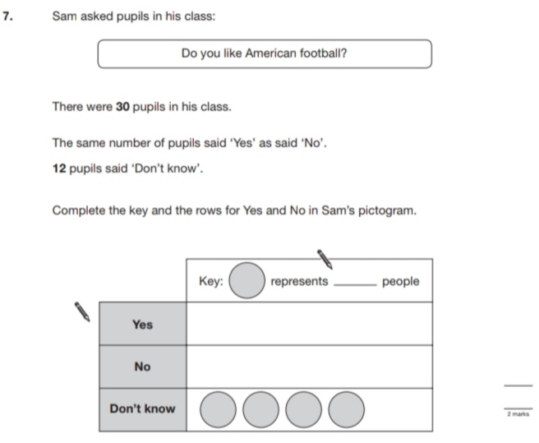
Key Stage 3: 2010 Paper 1 Level 3-5
9.
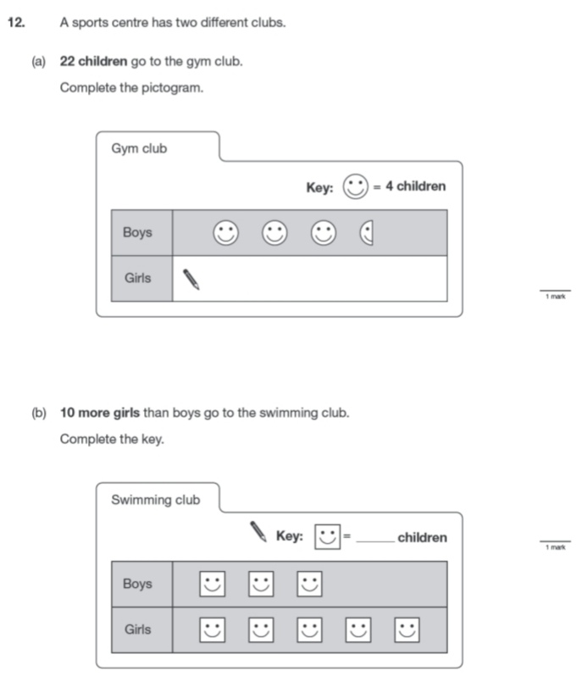
Key Stage 3: 2010 Paper 1 Level 4-6
10.
